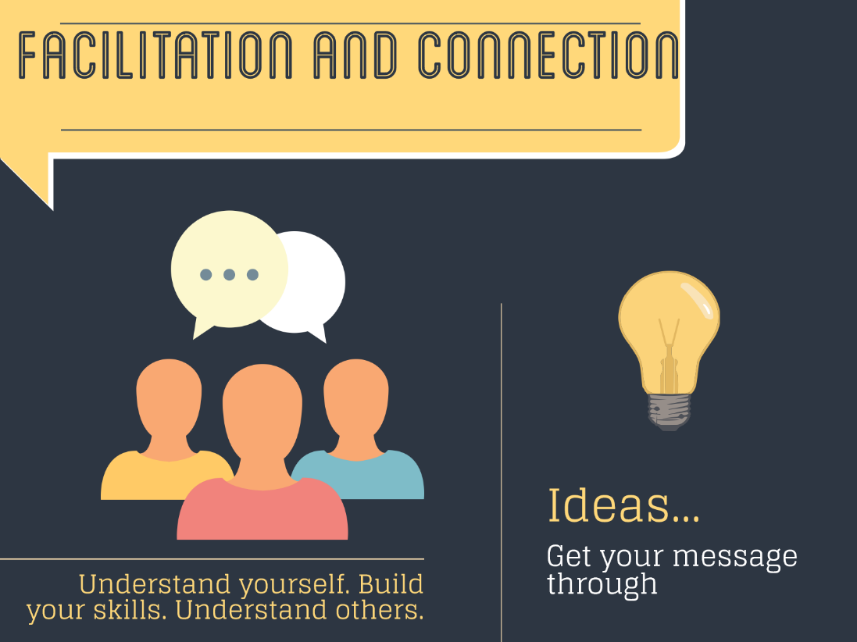
Professional Development in Client Communication and Facilitation Skills
Your Name | Your contact details
workplace learning project

2016

Workplace Learning Project

Purpose
To apply your learning throughout the program to ensure there’s ongoing practical impact long after our final workshop.

Outcomes
Development and implementation of your workplace learning project will enable you to:
- Have more chances to practice and test your skills and learning
- Strengthen your facilitation and communication skills through actively applying them in ‘your world’
- Continue to gain value from the program

Process
During the program you will have the opportunity to refine your workplace learning project. There are no hard and fast rules as to what it should cover. You’ll get most value if it draws on some of the skills that will be covered early on i.e. either Facilitation or Event Design.
Before we start, please set aside 30 minutes on uninterrupted and focused time to think about an area of your work that:
- You’d like some help with
- Need to try a different approach
- Requires the input of others
Any of these could be a good starting point for a Workplace Learning Project.

To capture your ideas:
- Simply write each one on a post it note and place them on your desk, wall or window
- Don’t think too much about the ideas, just get them down
- Step back and review your ideas
- If there are any that are very similar, place them together in pairs or larger groupings
- Now look for obvious or recurring themes – these could be the basis of your Workplace Learning Project.
If you’re on a roll, use the template on the next page to develop the bones of your Workplace Learning Project. You’ll be able to get feedback on this on Day 2 of the course.

Draft Workplace Learning Project

Purpose
(What I want to achieve overall)

Outcomes
(The BIG three intended results)

Process
(How I’ll go about it)

People
(Who I need to involve)

Product
(What tangible ‘things’ that it will generate)

Example project

Purpose:
To apply my knowledge gained from the facilitation training to overcome the current delays in resource allocation for activities requested by the two branches.

Outcomes:
- Prioritization of requests for resources from the two branches to each other
- Improved predictability of resource availability and request turnaround times.
- Improved communication between Systems Development and Technical Computing branches.

Process:
- Plan a facilitation session with people from the two branches.
- Run a brainstorming session
- Use ORID tool for debrief.

People:
Who to involve:
- Supervisor
- Branch managers and staff

Product:
- One page summary outlining the groups ideas on how to manage and prioritise requests for resources
- Outline of next steps to work through ideas and develop agreed procedures

